Sustaining and Transforming Occupational Health  Wednesday 13th and Thursday 14th September 2017  at the Chesford Grange Conference Centre  http://www.qhotels.co.uk/our-locations/chesford-grange/ | 

Registration form
Please complete a registration form for each delegate attending the conference (including free places) and return to forumconferences@btinternet.com
(tel: 01255 862 038 or 07932 737 844 for enquiries)

YOUR DETAILS

TITLE |  | FIRST NAME |  | LAST NAME
JOB TITLE
EMPLOYING ORGANISATION
ADDRESS FOR CORRESPONDENCE
TEL NO
EMAIL
SPECIAL DIETARY OR ACCESS REQUIREMENTS
Please note that your name, job title, employing organisation and email will be included in the delegate list provided to sponsors – please tick here if you do not wish this information to be shared

YOUR BOOKING – please indicate your booking option

Full conference place – available for Network members only
(includes reception, dinner and accommodation on 13th, plus conference on 14th)
@ no cost as Network member (ie. one free place per organisation* or pre-paid with membership renewal)
@ £295 for additional Network member places
Day delegate place (includes attendance at conference only on 14th)
@ no cost as Network member (as above)
@ £150 for additional Network member places
@ £295 for non-Network member places
* One free full or day delegate place per organisation is available to NHS Health at Work Network members as a standard membership benefit

PAYMENT

By cheque - payable to the NHS Health at Work Network and posted, with a copy of your registration form, to NHS Health at Work, PO Box 642, BS23 9NG

By invoice

Invoicing address:

Purchase order no:

SIGNATURE.................................................................................................................. DATE.........................................

Cancellation policy: No charge will be made for notification received more than 4 weeks before the event. 60% will be charged if written notification received between 2 and 4 weeks before the event. Charges in full will be made for notification less than 2 weeks before the event.
We are always happy for substitute delegates to attend but replacements should be advised to us in advance in order to avoid any confusion.

The NHS Health at Work Network conference is organised by | 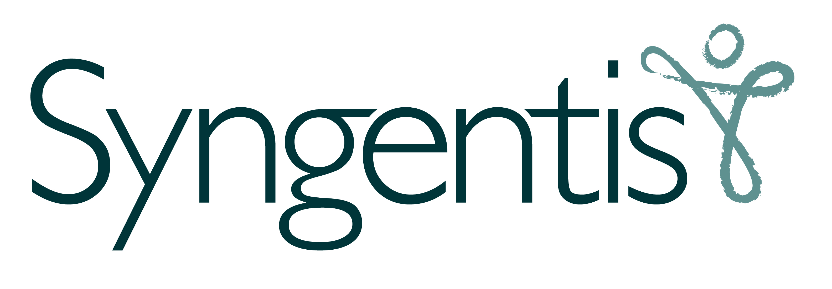 www.syngentis.co.uk | the not-for-profit health and work social enterprise

